Shreyas Bharadwaj

UID: 705 342 716

CS 32 Winter 2020

Homework 5

* 1. 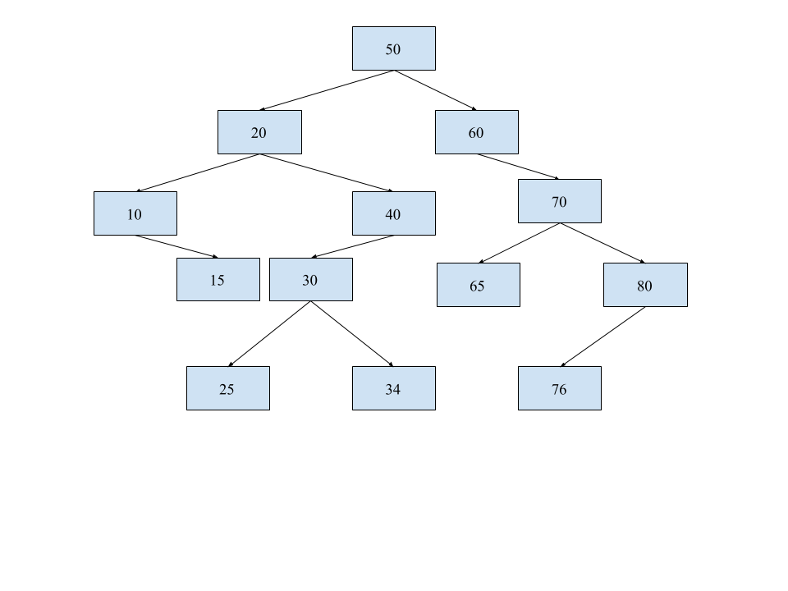
     1. Pre-Order Traversal: 50, 20, 10, 15, 40, 30, 25, 34, 60, 70, 65, 80, 76
     2. In-Order Traversal: 10, 15, 20, 25, 30, 34, 40, 50, 60, 65, 70, 76, 80
     3. Post-Order Traversal: 15, 10, 25, 34, 30, 40, 20, 65, 76, 80, 70, 60, 50
  2. 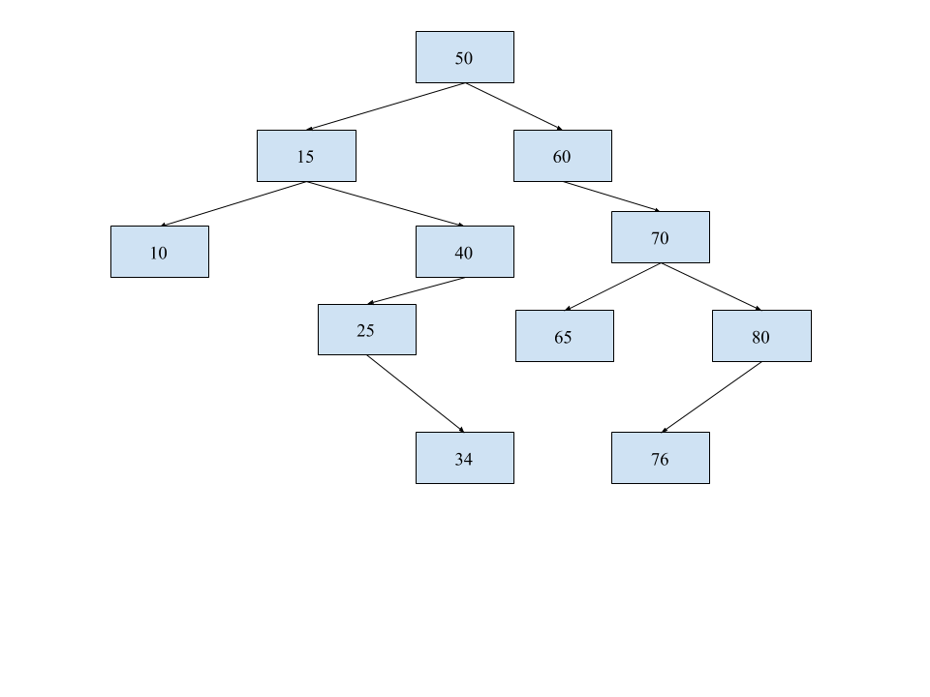
  3. struct Node {

Node(): data(0), left(nullptr), right(nullptr), parent(nullptr) {}

Node(int x): data(x), left(nullptr), right(nullptr), parent(nullptr) {}

int data;

Node\* left, right, parent;

};

* 1. void insertNode (Node\* curr, int num) {

if curr pointer is nullptr

create new Node with num as data

return

else if num is greater than curr’s data:

if curr’s right Node\* is nullptr

Create new Node with num as data

Set new Node’s parent to curr

Set curr’s right Node\* to the new Node

return

otherwise

call insertNode with curr->right, num

else if num is less than curr’s data:

if curr’s left Node\* is nullptr

Create new Node with num as data

Set new Node’s parent to curr

Set curr’s left Node\* to the new Node

Return

otherwise

Call insertNode with curr->left, num

}

* 1. 
  2. 
  3. 
  4. (log
  5. log $C$ + log $S)$ = $O($ log $CS)$
  6. $O($ log $S)$
 $O(1)$

 $O(S+$ 7. log $C)$
  8. $O(S$ log $S)$
  9. $O(C$ log $S)$
  10. See list.cpp.
  11. The necessity of the second parameter in the listAll function comes from the fact that the string is concatenated every function call with the current class name. If there is no second parameter, nor a static variable in the class definition, nor any other method of storing this information, there is nowhere to add on the new subclass names. Hence, there is no way to store the information needed to form or print the full string of classes followed by their subclasses, because there’s no way to keep track of the superclass’s name.